FREQUENCY POLYGONS
Pearson Edexcel - Tuesday 11 June 2019 - Paper 3 (Calculator) Higher Tier
1.
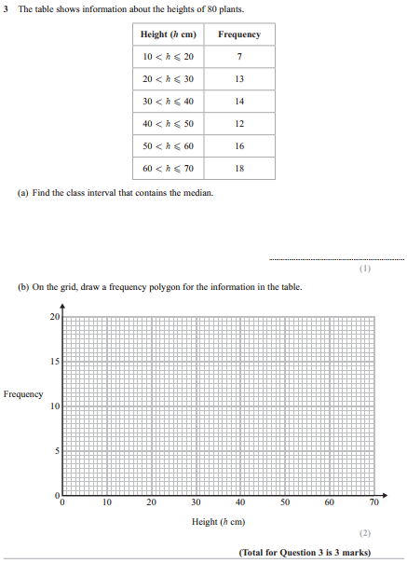
Pearson Edexcel - Monday 12 November 2018 - Paper 3 (Calculator) Higher Tier
2.
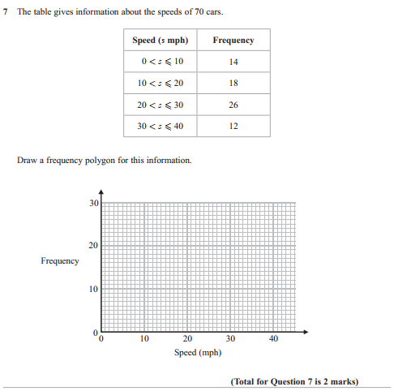

Pearson Edexcel - Wednesday 8 November 2017 - Paper 3 (Calculator) Higher Tier
3.
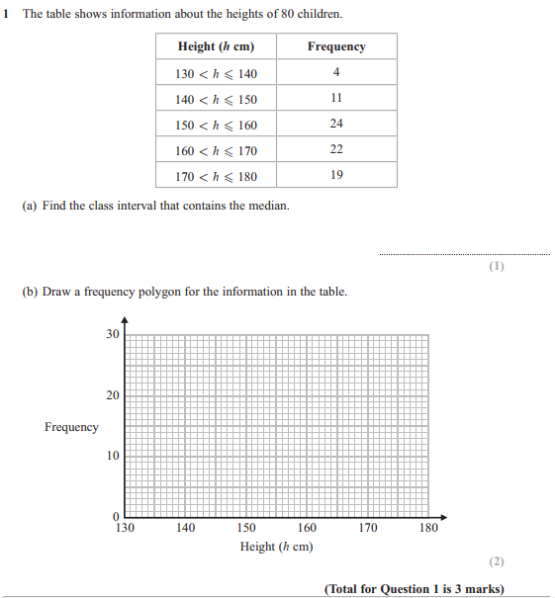

Pearson Edexcel - Specimen Papers Set 1 - Paper 2 (Calculator) Higher Tier
4.
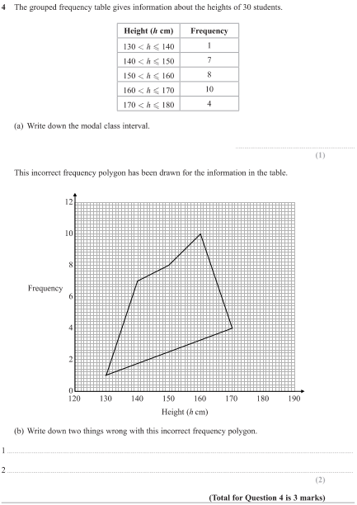

Pearson Edexcel - Monday 8 June 2015 - Paper 2 (Calculator) Higher Tier
5.
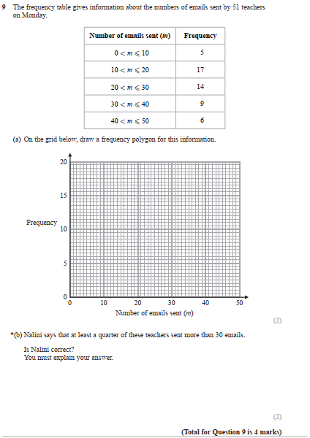

Pearson Edexcel - Friday 7 November 2014 - Paper 2 (Calculator) Higher Tier
6.
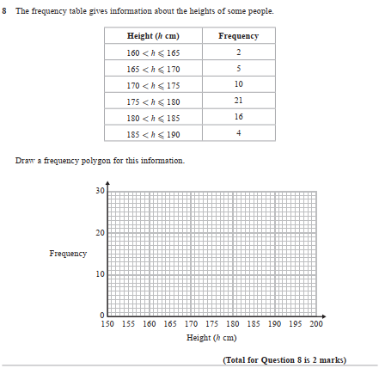

Pearson Edexcel - Friday 8 November 2013 - Paper 2 (Calculator) Higher Tier
7.
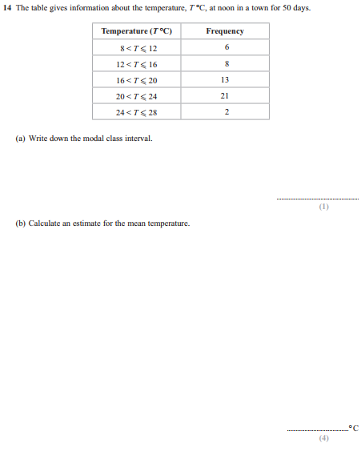
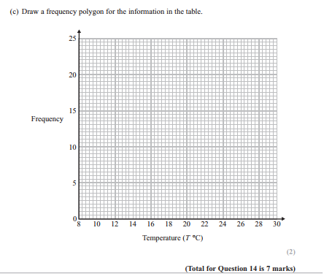

Pearson Edexcel - Thursday 8 November 2012 - Paper 2 (Calculator) Higher Tier
8.
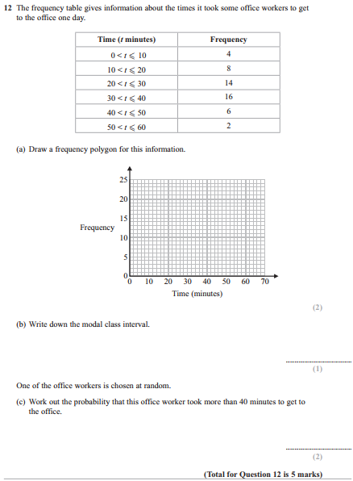

Pearson Edexcel - Friday 2 March 2012 - Paper 3 (Non-Calculator) Higher Tier
9.
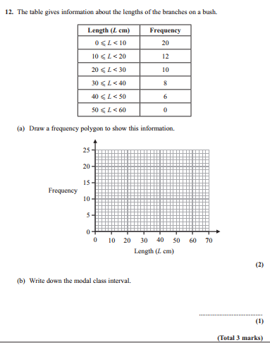

Pearson Edexcel - Monday 6 June 2011 - Paper 3 (Non-Calculator) Higher Tier
10.
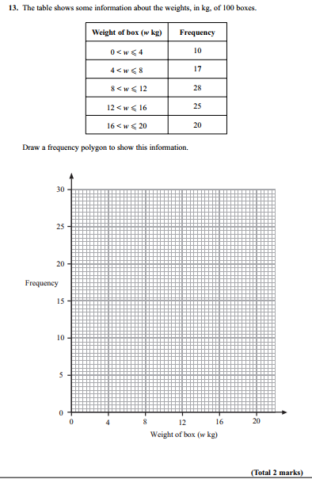

Pearson Edexcel - Friday 12 November 2010 - Paper 4 (Calculator) Higher Tier
11.
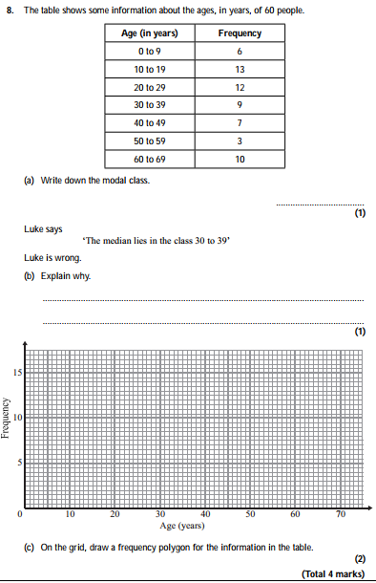

Pearson Edexcel - Monday 7 June 2010 - Paper 3 (Non-Calculator) Higher Tier
12.
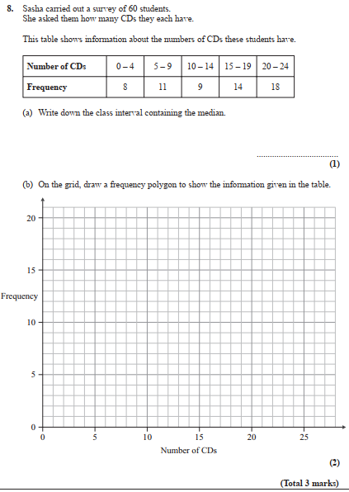

Pearson Edexcel - Thursday 5 November 2009 - Paper 3 (Non-Calculator) Higher Tier
13.
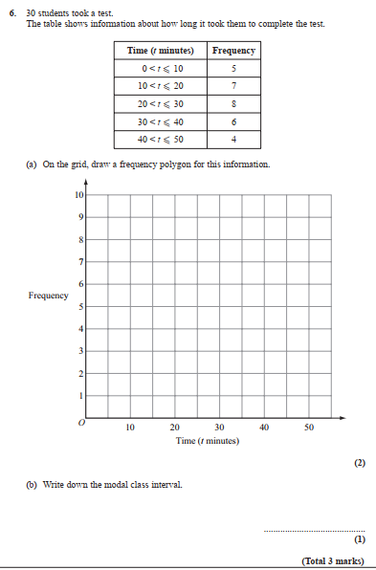

OCR GSCE – Tuesday 3 November 2020 – Paper 4 (Calculator) Higher Tier
14.
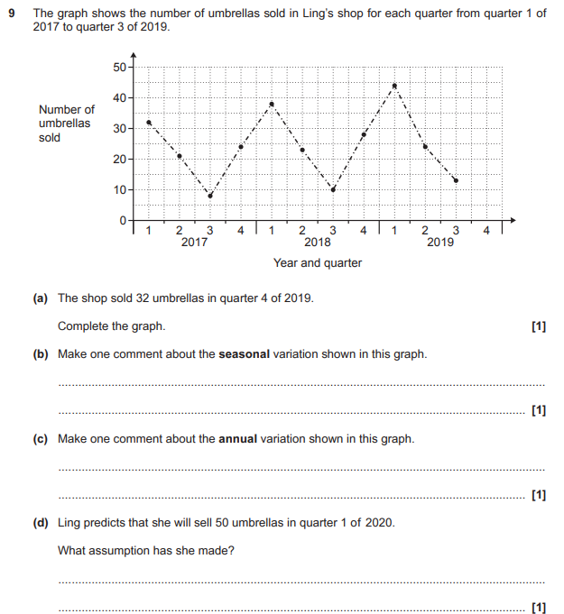

OCR GSCE – Tuesday 21 May 2019 – Paper 4 (Calculator) Higher Tier
15.
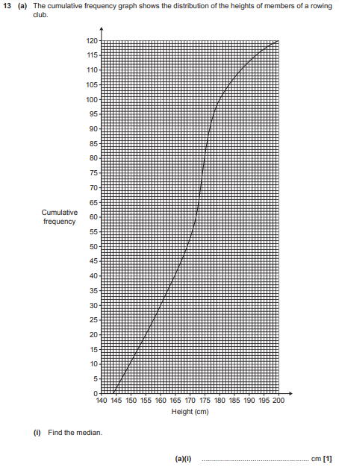
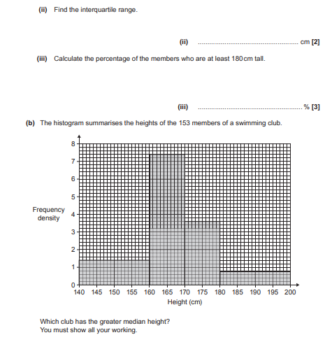

OCR GSCE – Thursday 8 November 2018 – Paper 5 (Non-Calculator) Higher Tier
16.
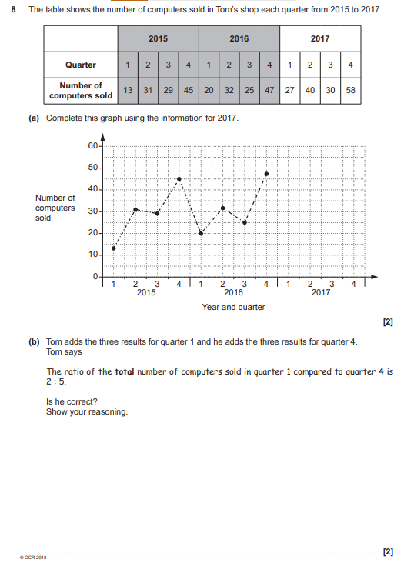
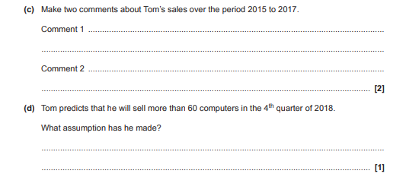

OCR GSCE – Thursday 25 May 2017 – Paper 4 (Calculator) Higher Tier
17.
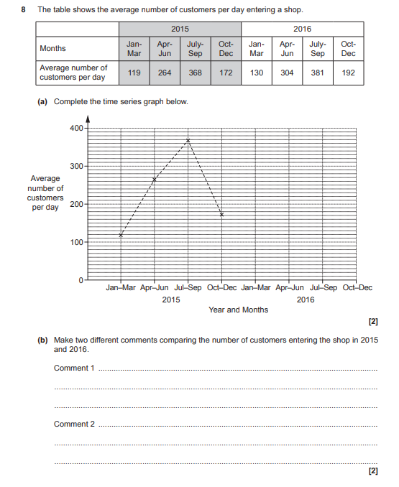

AQA GSCE – Thursday 4 June 2020 – Paper 2 (Calculator) Higher Tier
18.
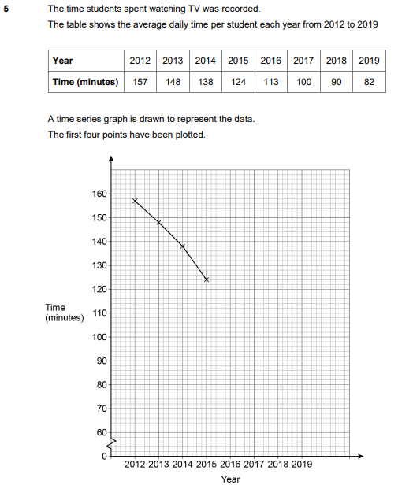

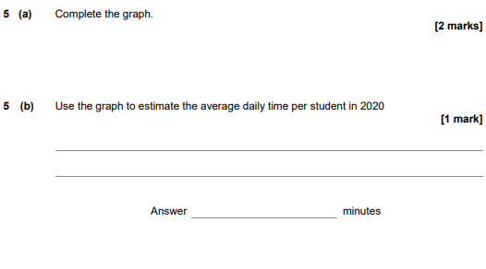

AQA GSCE – Monday 12 November 2018 – Paper 3 (Calculator) Higher Tier
19.
